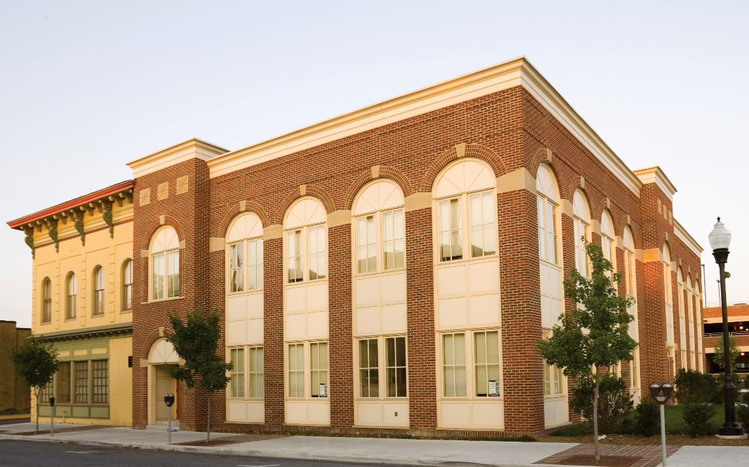

**O**

**P**

**E**

**N**

**H**

**O**

**U**

**S**

**E**

**The Shockey Building, Our Health Campus**

**301 N. Cameron Street**

**Come tour the newly renovated spaces of:**

**• *Just Neighbors • Concern Hotline***

***• I’m Just Me Movement • Literacy Volunteers***

**Thursday, March 27, 2025**

**2:00 pm to 5:00 pm**

**3:00 pm**

**Program & Ribbon Cutting**

***With Top of Virginia Regional Chamber of Commerce***

**Our Health *GreenSpace***

**Light refreshments will be served.**